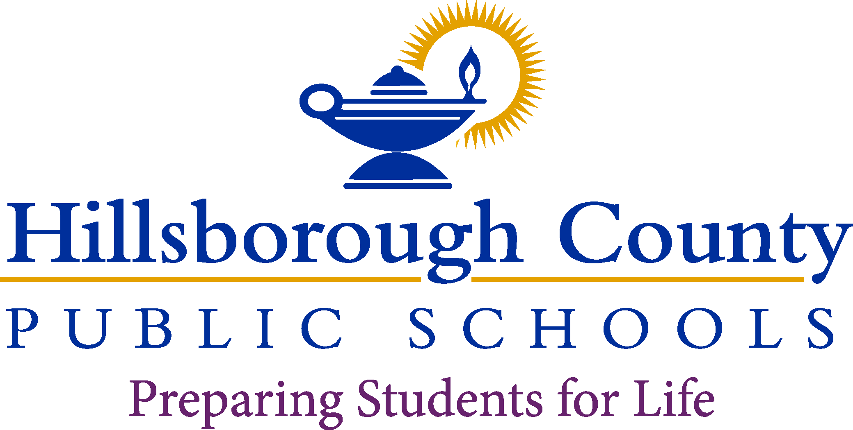

**Superintendent of Schools**

Addison G. Davis

**School Board**

Nadia T. Combs, Chair

Henry “Shake” Washington, Vice Chair Lynn L. Gray

Stacy A. Hahn, Ph.D.

Karen Perez

Patricia “Patti” Rendon

Jessica Vaughn

**CHIARAMONTE ELEMENTARY SCHOOL**

February 13, 2023

Dear Parent/Guardian:

All educators in Florida are monitored to ensure they meet certification and training requirements as mandated by law. Per Florida Statute 1012.42, when a teacher is assigned teaching duties out of the field in which the teacher is certified, the parents of all students in the class shall be notified in writing.

Hillsborough County Public Schoolsis committed to providing quality instruction for all students and does so by employing the most qualified individuals to teach and support each student in the classroom. The district is assisting our teachers by developing an *Individual Professional Development Plan* to complete the requirements needed to become in-field.

All of our teachers are certified to teach, although some of them are currently out-of-field and are working on additional areas of certification. You have the right to know the professional qualifications of the teachers or paraprofessionals who instruct your child. Federal law allows you to ask for certain information about your child’s teachers and requires us to give you this information in a timely manner if you ask for it. If you would like more information, please contact the school at

813-272-3066.

The table below lists teachers who are currently out-of-field.

Sincerely,

Cassie Smallen

Cassie Smallen

Principal

|  |  |  |  |  |
| --- | --- | --- | --- | --- |
| **Teacher** | **Classes Taught**  **Assignment(s)** | **Assignment Start Date** | **Certification(s) Held** | **Out-of-Field**  **Area/Classes** |
| Abigail Grover | 1st Grade | 8/2/2022 | Elementary Education | ESOL |
| Brett Yonkee | PreK ESE | 8/2/2022 | Elementary Ed, ESOL, ESE | PreK/ Primary Education |
| Ashley Adams | Access 2nd & 3rd | 8/2/2022 | Exceptional Student Education, Visual Impaired | Elementary Education,  ESOL |
| Sarah Garrison | 1st Grade | 8/2/2022 | Elementary Ed | ESOL |
| Naomi Porter | 3rd Grade | 8/2/2022 | Elementary Ed | ESOL |
| Sarah Putnam | School Counselor | 12/22/22 | In process | ESOL |